1. Tell me about your self?
S – Skills
E – Educational
A-Achievements
T-Type of person you are

- SKILLS:
  - am grateful for the opportunity to apply for this position. I am a hard- working, loyal, ambitious, collaborative team worker who takes the lead during challenges.

- EXPERIENCE/EDUCATION:
My educational qualifications and experience are an
excellent match for the job description. I have experience working as a team, completing timesensitive projects and delivering outstanding customer service.

- ACHIEVEMENTS:
  - am a high achiever. For example, in my previous position, I was praised by my manager for being flexible in my job description, how I took care of company supplies and resources to help save money, and helped train new team members.

- TYPE OF PERSON:
If you hire me, I will act as a positive role model for your company, take ownership of my professional development and embrace change to ensure the business becomes a market leader

- When have you failed?
In my first ever job, I failed a simple task given to me by my supervisor. They did give me a simple task to complete, but in my hastiness to get it completed quickly to impress, I failed to listen fully to the brief.
As soon as I realized this, I informed my supervisor apologized and asked them to repeat the brief before completing the task correctly, I learned a lot from that experience and since then, I listen to instructions carefully and take comprehensive note.

- How do you manage conflict?
Conflict has the potential to hinder a team’s performance. Therefore ,I take ownership of the situation to find a solution. First, I assess my words and actions to ensure I am not causing conflict. I then sit down privately with the person who the conflict is with to ascertain their views and options and to determine why the conflict is occurring. I then hold open and honest discussions to find and amicable way forword that empowers the team to prograss.

- What are your weakness?
My weakness are saying YES to people and PUBLC SPEAKING. When someone asked me to take on extra work or responsibilities, I always say Yes, Which sometimes means I overcommit. I am aware of this weakness and trying to force myself to access my capacity for additional work before committing.
I am not yet confident in public speaking , But I want to develop this skill. If there are any opportunities for me to give talks or presentations to my team in this role, I would like to try.
or
"My weaknesses are public speaking and difficulty expressing NO to people. I don't yet have any experience giving talks, but if there are any opportunities in this role for me to give a presentation to my team during projects, I would like to try.
I also struggle to say, NO to people which sometimes means I take on too much work. I am aware of this weakness and am taking steps to be more mindful of assessing my capacity for additional work before committing
5. What motivates you?
I am motivated by three things, Being fit and healthy, doing a great job for my employer and supporting my family. Being fit and healthy means I feel good about myself, and my energy and concentration levels are high. If I do a great job for my employer , I will receive praise , Job satisfaction, job security and a fair salary that will enable to support my family.

6. Why do you want this job?
I want this job for two reasons. The first reason is that the role perfectly aligns with my skills, knowledge and qualifications. I am passionate about this industry and I will have plenty of job satisfaction in my work.
The second reason I want this job is because it is with your company. I researched your company before submitting my resume. I was attracted to your company values , positive workplace and how you provide excellent training to ensure all staff reach their full potential.
Or "I am interested in this position for several reasons. The first reason is, having researched your company, I am confident I can build a long-term career here while collaborating alongside other likeminded professionals who want to do great things in their work. We spend a lot of time at work, and I would like that time to be spent producing work that makes a difference. I also want this job because this is an industry I am passionate about. My educational background and experience align perfectly with the job description and your workplace culture and company values mean I will be supported, and my ideas valued and trialed."

- Do you have any questions?

- What are the primary challenges faces by the team here?
- Can you describe a typical day or week in this position?
- How does this role contribute to the overall success of the company?
- Can you tell me more about the team I will be working with?
- How would you describe the team’s dynamic and working style?
- What are the team’s biggest achievements in the past years?
- How would you describe the company culture?
- What are the company’s short time and long time goals?
- How is success measured in this role?
- What opportunities are there for professional development and growth within the company?
- How do you see this role evolving over the next few years?
- What are the potential career paths within the company for someone in this position?
- Is there anything else you need from me to help make your decision?
- What are the next step in the interview process?
- When can I expect to hear back from you?

- What are your greatest strengths?
"My greatest strengths are an excellent match for the job description and person specification. I take the lead when problems occur instead of leaving them for others to with.
I am responsive. If you give me a task to complete, it will be done on time and to a good standard. I am a creative problem solver who analyzes information and facts to achieve the best outcome for the team.
Finally, my strong collaboration skills are a testament to my commitment to the team's success. I quickly fit into a team, act selflessly, and work hard to help my employer achieve their commercial and financial goals.

9. What do you know about our company?
"I researched your company extensively before submitting my resume for this position. I looked at your website to learn about your products and services. Your best-selling products are (INSERT NAME OF PRODUCT), and your customer reviews are excellent.
A common theme with reviews is the quality of your products and excellent customer service. I learned your company values and got a basic understanding of your mission. I also followed you on social media and was impressed that you have won awards for innovation and are active in the local community."

- How would you deal with a conflict with a co-worker?
"Conflict has the potential to hinder a team's progress. Therefore, I would take swift action to resolve it amicably. First, I would assess my words and actions to ensure I wasn't the cause.
Second, I would meet privately with my co-worker to ascertain their views and establish the conflict's cause. Finally, I would hold open and honest conversations with my co-worker to find a way forward that benefitted the team. After resolving the conflict, I would reflect and learn from the situation, So it did not reoccur.”

- Where do you see yourself in five years?
"I see myself working for you in this role, or having earned promotion to a higher level. In five years, I would have completed several training courses to enhance my skills, collaborated with different people on various projects, and be seen as a high- performing, trustworthy and integral employee.
In five years, I would also see myself as someone who could be used by the company to help train and develop new employees whenever they join the team."

- Why should we hire you?
"You should hire me because I am a trustworthy person who can be relied upon to carry out my work on time and to expected standards
You should hire me because I am hungry to learn, want to be the best I can be, and will support my coworkers to achieve a common goal. Finally, you should hire me because I want long-term employment with your company. This means I can become an integral part of the company's long-term success and you won't have to readvertise the position for many years to come."

- How do you handle stress and pressure?
"I handle stress and pressure at work by remaining calm, prioritizing each task against the project or team's objective, blocking out distractions and focusing on the goal.
When assessing my workload, I foresee problems and issues before planning accordingly. I also handle stress and pressure by accessing the skills and strengths of co-workers when I encounter problems. I believe that stress is an emotion I can control, and I never allow it to hinder my work performance."

14.Do you prefer to work independently or as part of a team?
"I am comfortable working alone and as part of a team and can easily switch between the two. Working alone, I prioritize tasks and get on with what I need to do.
When working as a team, I focus on the team's goal, establish what I can do to help achieve it, and support co-workers. If I had to choose between working independently or as part of a team, it would be working as a team."

15. When can you start?
"I am ready start work immediately. I have studied the requirements of the job and my personal life is such that I am free to work the specified hours and some overtime if and when required."

16. Why are you interested in this position?
I am interested in this position for several reasons The first reason is , Having researched your company, I am confident I can build a long-term career here while collaborating alongside other like-minded professionals who want to do great things in their work. We spend a lot of time at work, and I would like that time to be spent producing work that makes a difference. I also want this job because this is an industry I am passionate about. My educational background and experience align perfectly with the job description and your workplace culture and company values mean I will be supported, and my ideas valued and trialed.

- 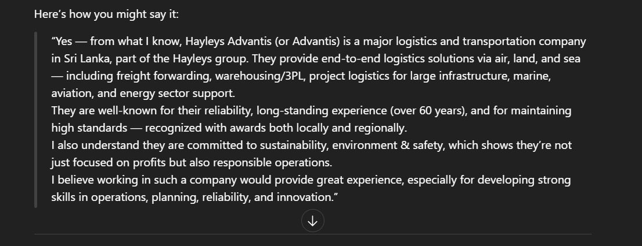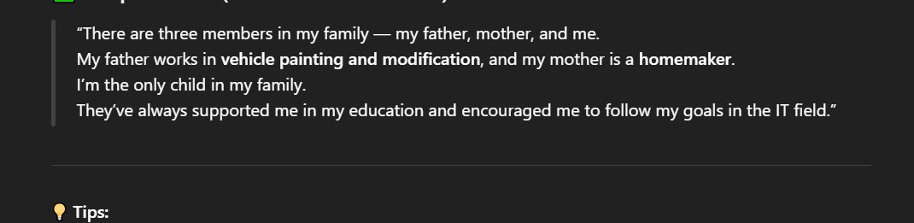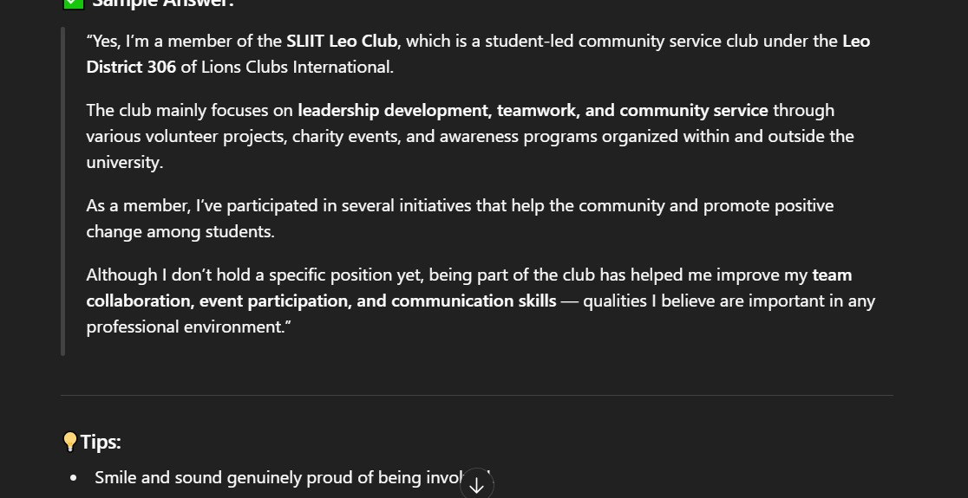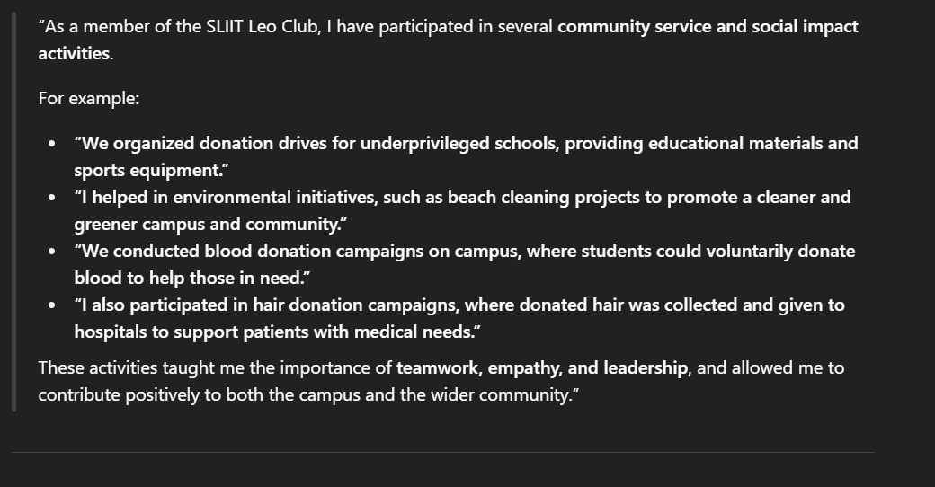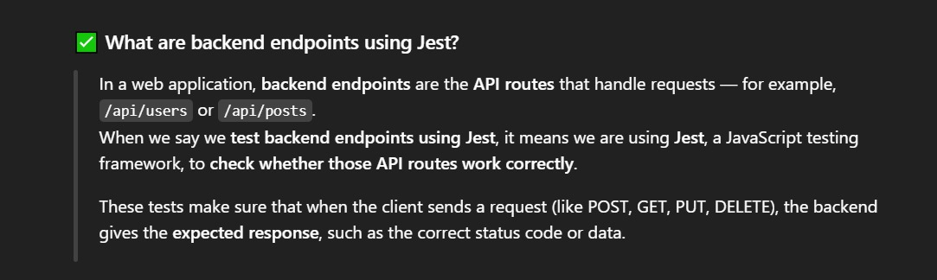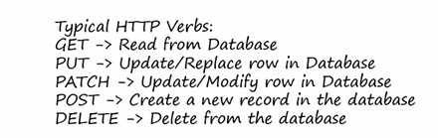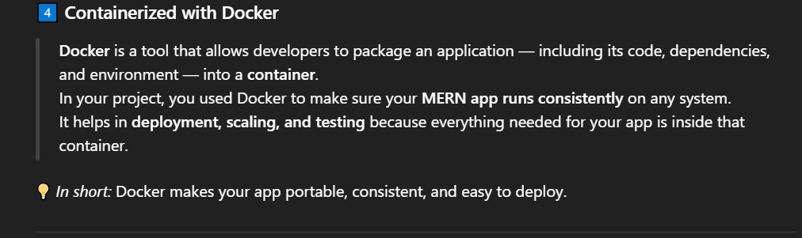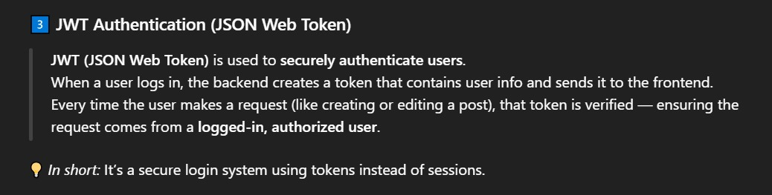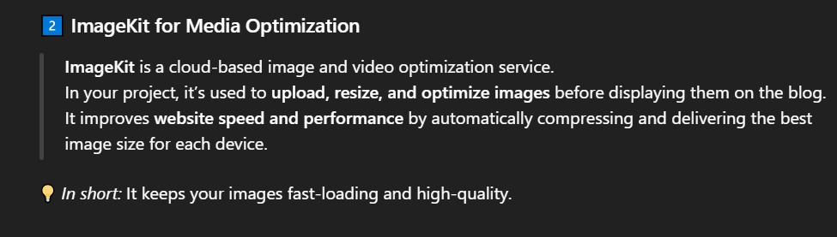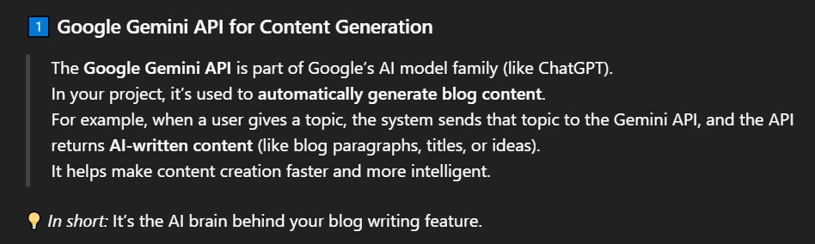

“In our Real Estate Management System group project, one of the main challenges we faced was managing version control using GitHub.

Initially, we created a repository and separate branches for each member, but some teammates accidentally merged their unfinished code directly into the main branch. This caused conflicts and errors in the project.

To solve this, I suggested we use a proper branching strategy — where everyone works on their own branch, and we only merge through pull requests after reviewing the code. We also decided to test the code before merging into the main branch.

After applying this, our workflow became much smoother, and we could collaborate without breaking the project.”

For example, in one of my group projects — the Real Estate Management System — one challenge was coordinating version control among team members when we first started using GitHub. Sometimes our code conflicted when merging branches. To solve this, I suggested we follow a branching strategy, assign clear responsibilities, and have regular code reviews. That improved collaboration and reduced errors.

In another project — my individual MERN Stack project for a Customer Account Management System — I faced a backend integration issue where API data wasn’t displaying correctly on the frontend. I learned to debug using browser dev tools, check API responses, and use Postman to test endpoints. It taught me the importance of systematic debugging and testing.

Overall, these challenges improved my problem-solving skills, teamwork, and confidence in handling both technical and communication issues during development.”

java project
user account management
ticket reservation management
train details management
payment management

API- A software interface which facilitates communication between two or more
applications.

Representational State Transfer API (REST API)
Simple Object Access Protocol API (SOAP API)

REST API - an architectural style for creating web services.
Runs on HTTP Protocol

“HTML stands for HyperText Markup Language.
It’s the standard language used to create the structure of web pages.
It defines elements like headings, paragraphs, images, and links that make up the content of a webpage.

CSS stands for Cascading Style Sheets.
It’s used to style and design HTML elements — for example, changing colors, fonts, layouts, and spacing.

JavaScript is a programming language used to make web pages interactive and dynamic.
While HTML builds the structure and CSS adds style, JavaScript adds functionality and behavior — like responding to button clicks, validating forms, showing alerts, or updating content without reloading the page.

It provides predefined CSS classes that you can directly apply in your HTML or React components to style elements — without writing long custom CSS files.

